## Verify CI flow

# Navigate to pipeline sd3500_msa_frontend/main => Build Now

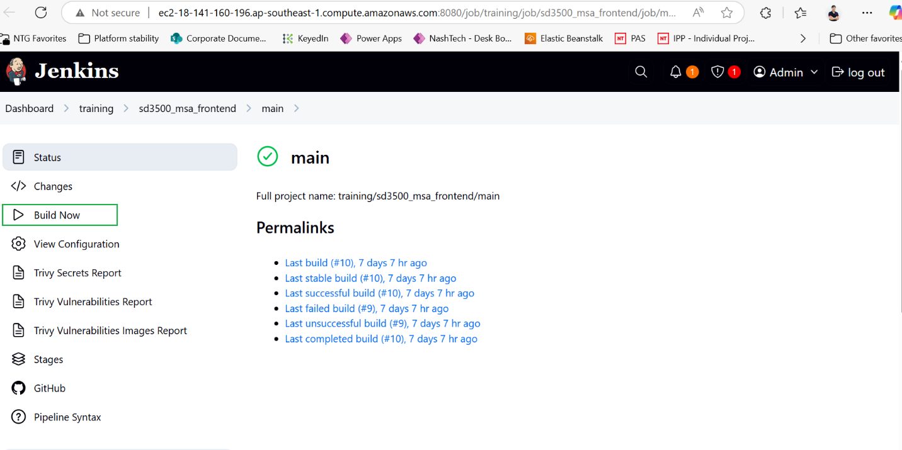

After pipeline run completed

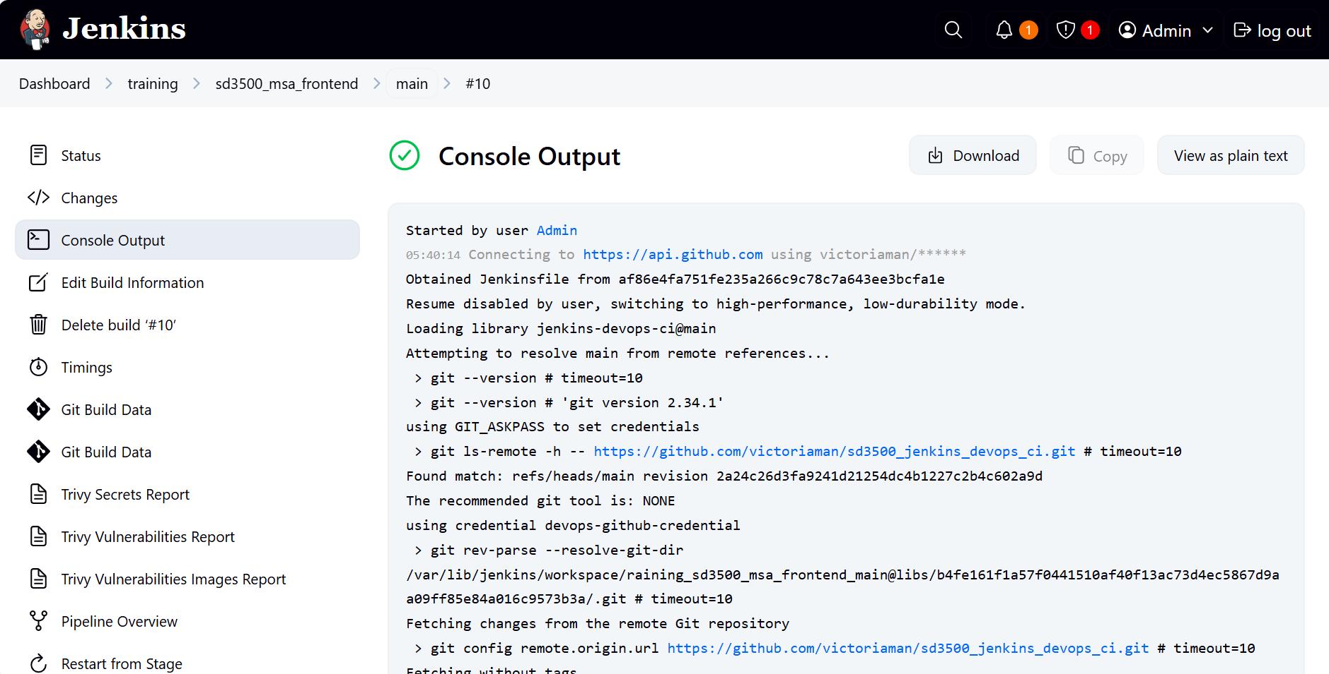

# Tag of Docker image is printed in console log

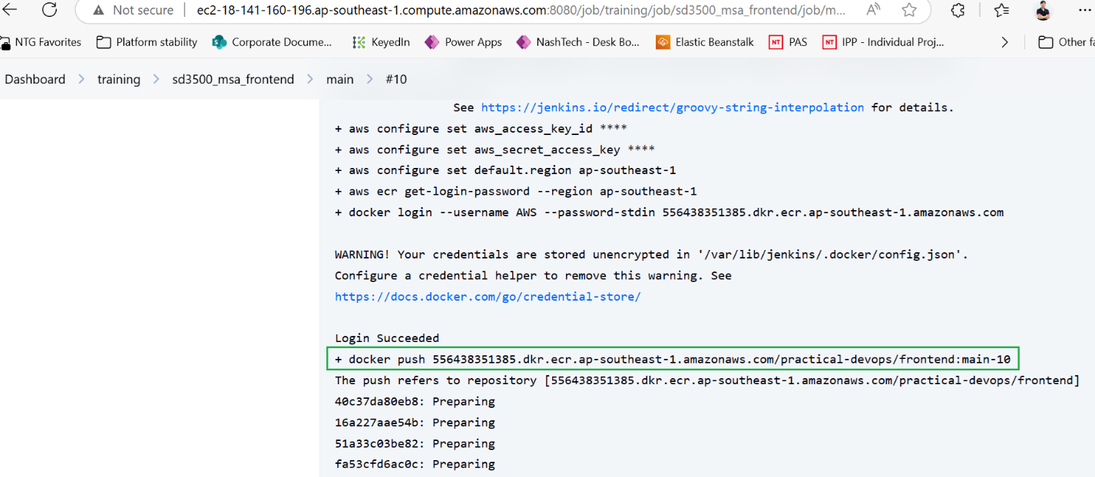

# Click Trivy Vulnerabilities Report to view detail report

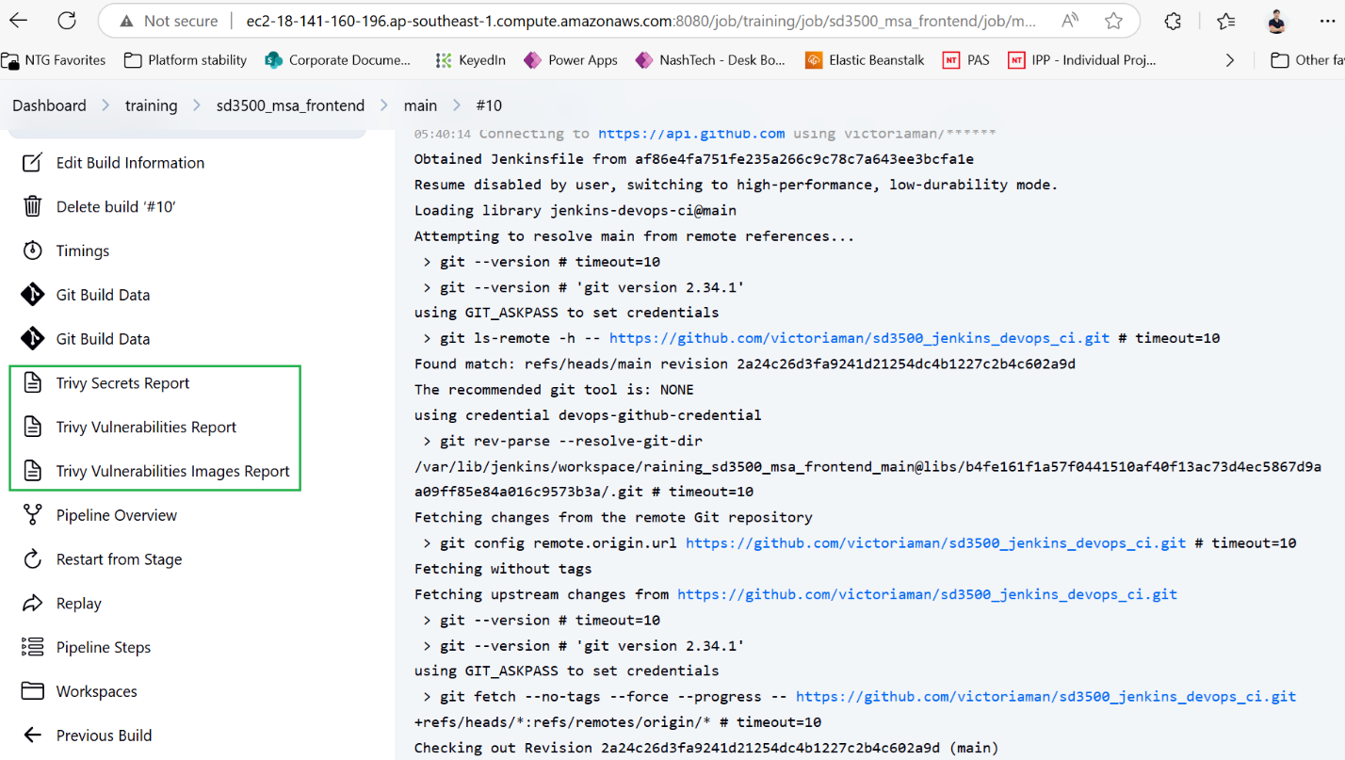

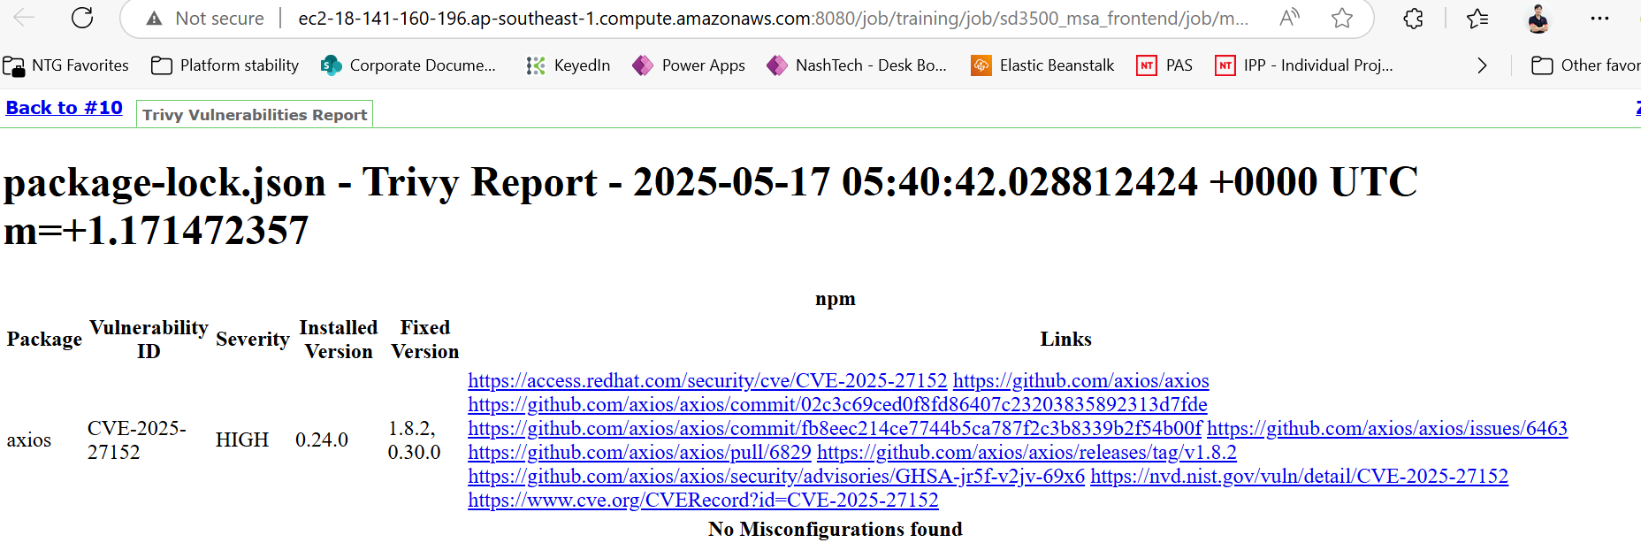

# Check new image is published to AWS ECR

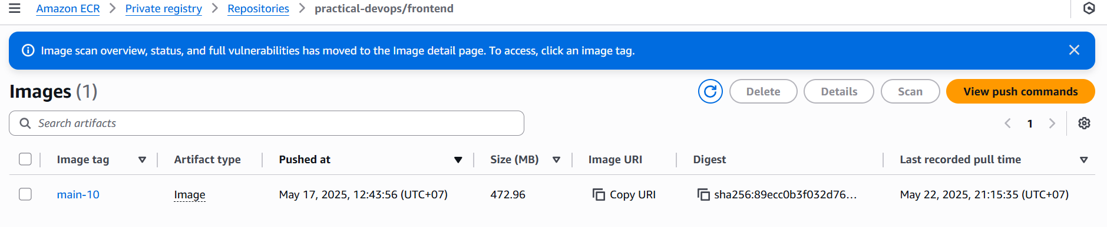

## Verify CD flow

# Update image tag in [sd3500_gitops/jenkins/prod/frontend.yaml at main · victoriaman/sd3500_gitops](https://github.com/victoriaman/sd3500_gitops/blob/main/jenkins/prod/frontend.yaml) with the tag from latest image in AWS ECR

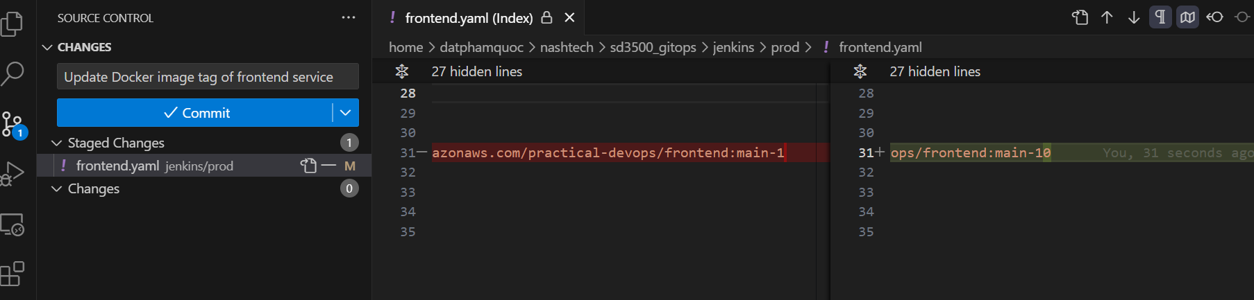

# Navigate to pipeline => Build Now

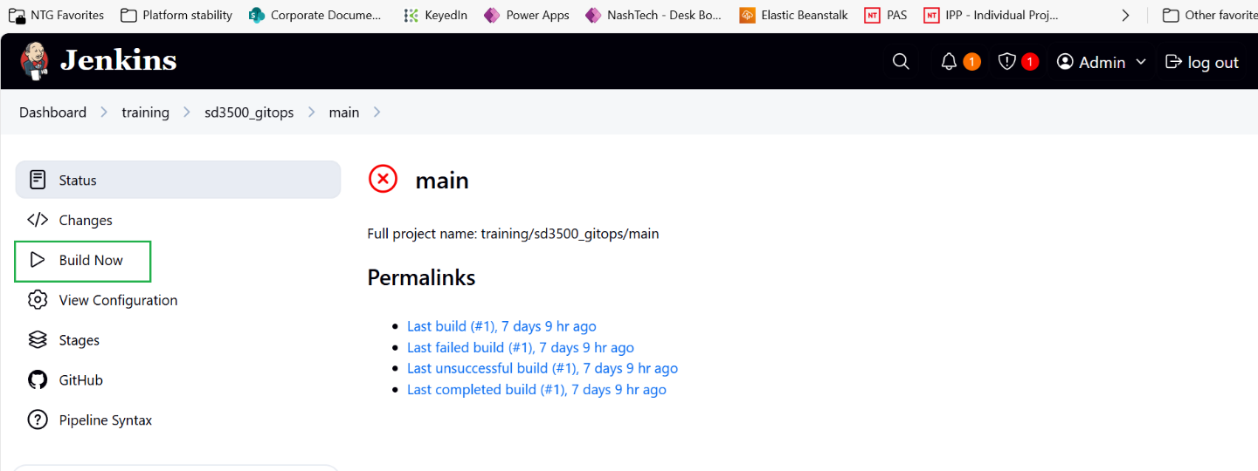

After pipeline run completed

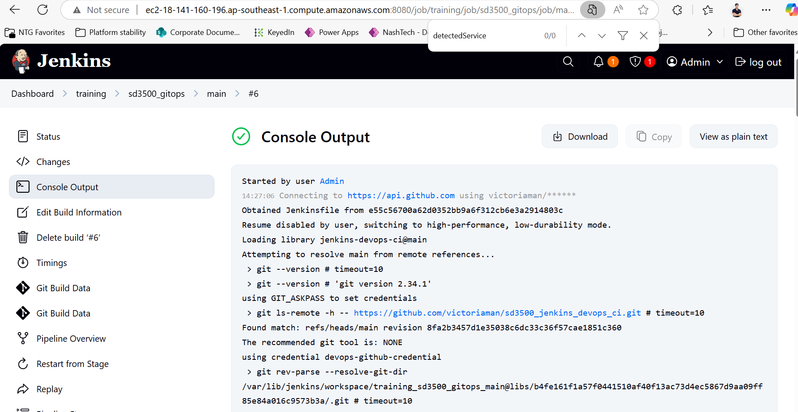

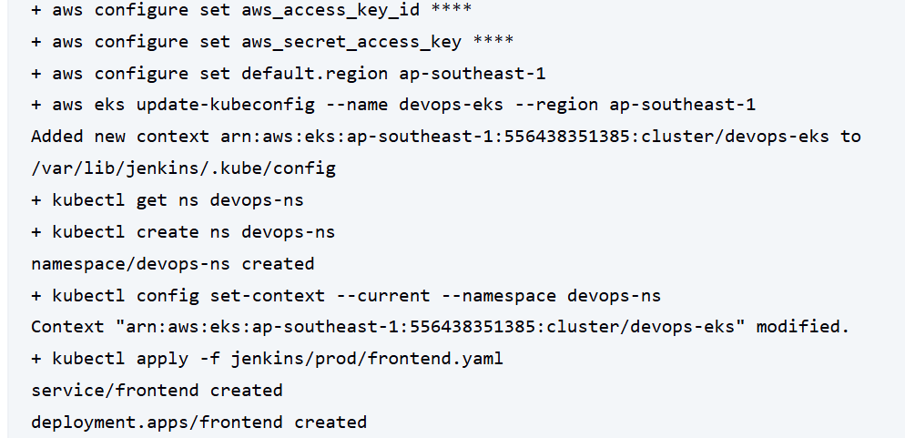

**Open terminal to check frontend service in EKS**

# Switch namespace to devops-ns  
kubectl config set-context --current --namespace devops-ns



# Verify pod  
kubectl get pod



# verify frontend service

kubectl get service



# Application verification by exposing frontend service, expose frontend service to access application

kubectl port-forward service/frontend 3000:3000



# Access to <http://localhost:3000> to verify the frontend application, which is hosted in AWS EKS

